


Narrogin Senior High School
English Department



YEAR 11

GENERAL ENGLISH

EXTERNALLY SET TASK

PRACTISE 3

English

Externally Set Task Practise 1

Working time for the task: 50 minutes

Total marks: 40 marks

Weighting: 15% of the school mark

Read the article below.

All Your Scary Dreams Really Mean The Same Thing

There's one teensy-tiny problem...
Suzy Strutner Associate Lifestyle Editor, The Huffington Post Posted: 11/04/2015 11:44 AM EST | Edited: 11/04/2015 12:13 PM EST

Dreams have long mystified us, and their meanings can seem nearly impossible to decipher. So when we spoke with dream experts from the American Psychoanalytic Association to celebrate the 116th anniversary of Sigmund Freud's The Interpretation of Dreams, we had one question: What do our most common dreams really mean?
If you look at some of our most common dreams, they're fairly similar: falling, being chased, showing up late to work. While these actions could have positive spins, we often dream them in a nightmarish or negative manner. And according to the experts, it's likely that all these scary dreams mean the same thing: You're feeling anxious.

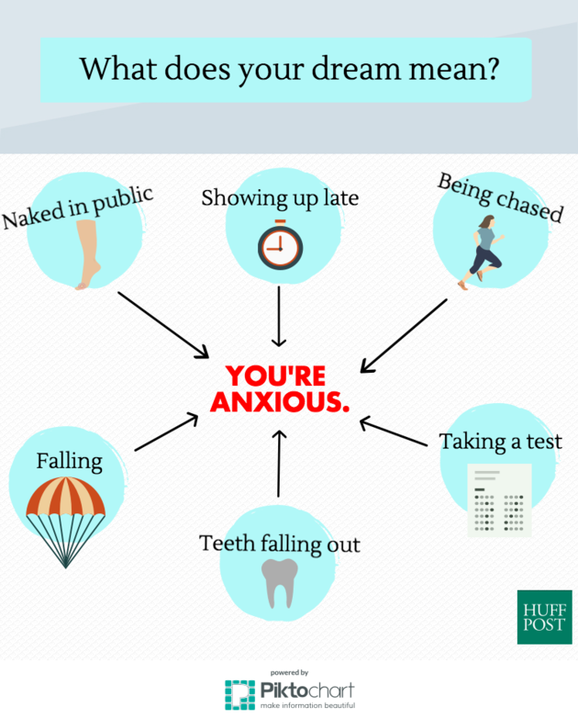
Huffington Post/Piktochart
It's tempting to read deeply into dreams, and they can have complex meanings. But the particular motifs listed above are very often associated with anxious feelings. You can pinpoint their specific meanings fairly easily, according to Dr. Prudence Gourguechon, a psychoanalyst and former president of the APsaA.
Before you start interpreting these dreams, there are a few things you should know:

Decoding your dreams requires focusing on yourself -- no matter who else is showing up in them.

"Dreams are narratives that illustrate what's going on in your life, nobody else's," Gourguechon explained to HuffPost. "They're a visual picture of the dreamer's inner state." So before you read into the scenario of who made you late to class in your dream, consider what being late means for you, and go from there.

Yes, you should take dream meanings literally.

Just as being nude in public means your body is exposed, a dream about it means you likely feel emotionally exposed. Maybe you're about to try something new or daring, and you're afraid you'll come up short. A dream about falling might mean you feel like you're losing your balance emotionally, as in a fear of failing or the onset of depression. Dream motifs won't mean the same thing for any two people, but they can be taken as starting points to think about your emotions.

Your dream may represent a wish, not an anxiety.

Early theory held that dreams are our deepest wishes. So if you can't pinpoint an anxiety associated to your dream symbol, then think about your desires, says psychologist and psychoanalyst Mark Blechner. If you're being chased in your dream, consider this: Do you long to be pursued romantically, and feel unfulfilled in that way? Likewise, a dream about taking a test could mean you'd like to show off your competency, at work or otherwise.

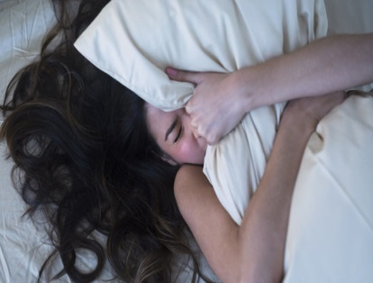
JGI/Tom Grill via Getty Images

Still stumped? Blechner recommends writing them down, thinking of your associations to the symbols in each dream and asking friends for their associations of you to those symbols. As Gourguechon says, "there is no cookbook." Understanding yourself is the best way to zoom in on the specific meaning of your dreams.

Respond concisely, in short answer format of approximately 200–300 words for each question, on the answer sheets provided in this booklet.
- Explain Suzy Strutner’s perspective presented in her article, “All Your Scary Dreams Really Mean The Same Thing.”. (20 marks)
________________________________________________________________________________
________________________________________________________________________________
________________________________________________________________________________
________________________________________________________________________________
________________________________________________________________________________
________________________________________________________________________________
________________________________________________________________________________
________________________________________________________________________________
________________________________________________________________________________
________________________________________________________________________________
________________________________________________________________________________
________________________________________________________________________________
________________________________________________________________________________
________________________________________________________________________________
________________________________________________________________________________
________________________________________________________________________________
________________________________________________________________________________
________________________________________________________________________________
________________________________________________________________________________
________________________________________________________________________________
________________________________________________________________________________
________________________________________________________________________________
________________________________________________________________________________
________________________________________________________________________________
________________________________________________________________________________
________________________________________________________________________________
________________________________________________________________________________
________________________________________________________________________________
________________________________________________________________________________
________________________________________________________________________________
________________________________________________________________________________
________________________________________________________________________________
________________________________________________________________________________
________________________________________________________________________________
_________________________________________________________________________________
_________________________________________________________________________________
_________________________________________________________________________________
_________________________________________________________________________________
_________________________________________________________________________________
_________________________________________________________________________________
_________________________________________________________________________________
_________________________________________________________________________________
_________________________________________________________________________________
_________________________________________________________________________________
_________________________________________________________________________________
_________________________________________________________________________________
_________________________________________________________________________________
_________________________________________________________________________________
_________________________________________________________________________________
_________________________________________________________________________________
_________________________________________________________________________________
_________________________________________________________________________________
_________________________________________________________________________________
_________________________________________________________________________________
_________________________________________________________________________________
_________________________________________________________________________________
_________________________________________________________________________________
_________________________________________________________________________________
_________________________________________________________________________________
_________________________________________________________________________________
_________________________________________________________________________________
_________________________________________________________________________________
_________________________________________________________________________________
_________________________________________________________________________________
_________________________________________________________________________________
_________________________________________________________________________________
_________________________________________________________________________________
_________________________________________________________________________________
_________________________________________________________________________________
_________________________________________________________________________________
_________________________________________________________________________________
- How does Suzy Strutner influence her audience to respond to her perspective on dreams? (20 marks)
________________________________________________________________________________
________________________________________________________________________________
________________________________________________________________________________
________________________________________________________________________________
________________________________________________________________________________
________________________________________________________________________________
________________________________________________________________________________
________________________________________________________________________________
________________________________________________________________________________
________________________________________________________________________________
________________________________________________________________________________
________________________________________________________________________________
________________________________________________________________________________
________________________________________________________________________________
________________________________________________________________________________
________________________________________________________________________________
________________________________________________________________________________
________________________________________________________________________________
________________________________________________________________________________
________________________________________________________________________________
________________________________________________________________________________
________________________________________________________________________________
________________________________________________________________________________
________________________________________________________________________________
________________________________________________________________________________
________________________________________________________________________________
________________________________________________________________________________
________________________________________________________________________________
________________________________________________________________________________
________________________________________________________________________________
________________________________________________________________________________
________________________________________________________________________________
________________________________________________________________________________
________________________________________________________________________________
________________________________________________________________________________
_________________________________________________________________________________
_________________________________________________________________________________
_________________________________________________________________________________
_________________________________________________________________________________
_________________________________________________________________________________
_________________________________________________________________________________
_________________________________________________________________________________
_________________________________________________________________________________
_________________________________________________________________________________
_________________________________________________________________________________
_________________________________________________________________________________
_________________________________________________________________________________
_________________________________________________________________________________
_________________________________________________________________________________
_________________________________________________________________________________
_________________________________________________________________________________
_________________________________________________________________________________
_________________________________________________________________________________
_________________________________________________________________________________
_________________________________________________________________________________
_________________________________________________________________________________
_________________________________________________________________________________
_________________________________________________________________________________
_________________________________________________________________________________
_________________________________________________________________________________
_________________________________________________________________________________
_________________________________________________________________________________
_________________________________________________________________________________
_________________________________________________________________________________
_________________________________________________________________________________
_________________________________________________________________________________
_________________________________________________________________________________
_________________________________________________________________________________
_________________________________________________________________________________
_________________________________________________________________________________
_________________________________________________________________________________

